**Lecture on Multinomial Regression**

**Professor Esfandiari**

The objective of this lecture is to…

1. Introduce you to multinomial regression and when it can be used.
2. Show you how to conduct multinomial regression in R and interpret the outputs.
3. Provide you with examples of multinomial with categorical and numerical predictors.
4. Provide you with examples of multinomial models with interaction between qualitative and qualitative as well as qualitative and quantitative predictors.
5. Give you exercises that allows you to review and interpret the results and plot.
6. Provide you with examples of plot of odds, how to interpret them
7. Calculation of accuracy using confusion matrix and splitting data into testing and training
8. What criteria to use to choose one model over another

**I Introduction**

In multinomial regression, the response variable has “m” categories. One of the categories is selected as “baseline” , and then fits the logistic regression models comparing each of the remaining categories with the baseline. As usual, R selects the first category as the baseline.

Suppose that we let $η_{j}$ (x) be the linear predictor for the comparison of category j with the baseline, j = 2, …,m; assuming that an intercept is included in the model.

$$η\left(x\right)=β_{0}j+β_{1j}x_{1}+…+β_{kj}x_{k}$$

The for j = 2, …,m

$\log_{e}$ = $\left\lceil pr\frac{Pr⁡(response in category j|x}{pr(response is baseline catefory 1|x}\right\rceil$ = $η_{j}$ (x)

In terms of probabilities, if $μ_{j}\left(x\right)= pr(response in category\left(j | x\right),$

$μ_{j}\left(x\right)=\frac{exp⁡[η_{j}\left(x\right)]⁡}{1+\sum_{l=2}^{m}{exp⁡[η_{j}\left(x\right)]⁡}}$ for j = 2,…,m

$μ_{l}\left(x\right)$ = 1 – $\sum_{l=2}^{m}{μ_{l}}\left(x\right) for j=1$

The log of the odds between any pair of response categories j and $j^{'}$# 1 is given as follows:

$\log_{e}\frac{μ_{j(x)}}{{μ_{j}}^{'}(x)η_{j}(x)}$ =

$\log_{e}\left\lfloor \frac{{μ_{j}(x)}/{μ_{l}(x)}}{{{μ_{j}}^{'}(x)}/{μ_{l}(x)}}\right\rfloor$ =

$\log_{e}\frac{μ_{j}(x)}{μ_{1}(x)}-\log_{e}\frac{{μ_{j}}^{'}(x)}{μ_{1}(x)}$ =

$η_{j}(x)-η_{j^{'}}(x)$ =

($β_{0j}-{β_{0}}_{j^{'}}$) = ($β_{1j}-{β_{1}}_{j^{'}}$) $x_{1}+…+ (β_{kj}-{β_{k}}_{j^{'}})x_{k}$

Thus, the logistic regression coefficients for the log of the odds in membership in category J vs. $j^{'} is given by the differences in the corresponding parameters in the of the$

multinomial logistic model.

**The multinomial logit model is not a traditional GLM and cannot be fit by the glm function. Instead we use the multinom function in the nnet package. Just as glm can fit regression models to both binomial and binary data, the multinom function can fit models in which the observations represent counts in several response categories, as one would have in a contingency table, or individual responses.**

**Example of multinomial regression with all the steps involved**

We will use the sex discrimination data to conduct a multinomial regression.

**Question to be answered**: If you could have only one child, can the preferred gender of that child be predicted from level of education and endorsing women for public office?

**Outcome variable: Preferred gender of only child. – AS YOU NOTICE THE OUTCOME VARIABLE IS CATEGORICAL AND HAS MORE THAN TWO LEVELS**

* Boy
* Girl
* Either

**Predictors:**

**Level of education**

* College
* No college

**Endorsing women for public office**

* Yes
* No

**Step one:** We need to check the frequency table of the outcome and categorical predictors

**> ftable(tab1<-xtabs(~boyorgirl+edur+femaleleader,data=sex_discrimination))**

femaleleader

boyorgirl edur No Yes

boy college 63 12

less than college 187 27

either college 63 60

less than college 112 54

girl college 52 21

less than college 128 15

**> (sexdis1<-data.frame(tab1))**

boyorgirl edur femaleleader Freq

1 boy college no 63

2 either college no 63

3 girl college no 52

4 boy less than college no 187

5 either less than college no 112

6 girl less than college no 128

7 boy college yes 12

8 either college yes 60

9 girl college yes 21

10 boy less than college yes 27

11 either less than college yes 54

12 girl less than college yes 15

**Step two:**

1. **Make a summary table and examine the cell frequencies for the categorical variables to make sure that they are reasonable.**

Cell frequencies resulting from the variables of interest

|  |  |  |  |
| --- | --- | --- | --- |
| Preferred gender of only child | Level of education | Endorsing women for public office | |
|
| Yes | No |
| Boy | College | 63 | 12 |
| No college | 187 | 27 |
| Either | College | 63 | 60 |
| No college | 112 | 54 |
| Girl | College | 52 | 21 |
| No college | 128 | 15 |

The cell frequencies look OK but not great. The cells including boy X college (N = 12) and girls X no college (N = 15) are smaller than the rest. There is not much we can do. We have already pooled the education category and endorsing women for public position to two categories. We could run this analysis and then pool the boy and girl category into one and compare it with either gender. But, it is interesting to see have boy and girl as separate categories.

1. **If you have any numerical predictors, examine the histogram to see if transformation in needed.**

In this case we do not have any numerical predictors.

**Step three - Running the multinomial model in R and when it is used**

The multinomial model is used when the outcome variable is a categorical variable with multiple levels such as “ethnicity, “political affiliation”, and “religion”.

The predictors can be numerical, categorical, as well as the combined effect of categorical with categorical and categorical with numerical.

We will use the **nnet library** and **multinom command** to carry out the analysis.

**Example one**. We want to create a multinomial model to answer the question of interest; namely examining the relationship between level of education (college vs. no college, and endorsing women for public office (yes vs. no), and the preferred gender of only child (boy, girl, either).

**R commands for running multinomial regression**

**> library(nnet)**

**> m1<-multinom(boyorgirl~edur+femaleoffice)**

**> summary(m1, Wald.ratios =TRUE)**

**Coefficients:**

(Intercept) No college femaleofficeyes

either -0.64 -0.45 1.21

girl -0.44 -0.10 0.17

**Std. Errors:**

(Intercept) No college femaleofficeyes

either 0.15 0.12 0.14

girl 0.15 0.13 0.13

**Value/SE (Wald statistics):**

(Intercept) No college femaleofficeyes

either -4.20 -3.82 8.49

girl -2.93 -0.73 1.31

Residual Deviance: 3663.048

**AIC: 3675.048**

**As you notice from the above, R created two logistic regression models are created making “boys” the baseline (reference).**

* The lines under coefficients show the intercept and the log of the odds for the model comparing preferred gender of the child to be either vs boy and girl vs boy.
* The second set of two lines correspond to the standard error of the coefficients reported in the first two lines
* The last three lines correspond to the Wald Statistics which are similar to the Z-values corresponding to each coefficient. For example
* Wald statistics for either gender and no college would be = -0.45356462/0.1187044 =

-3.820959.; which is statistically significant indicating the log of odds of preferring the gender of the only child to be either a boy or a girl compared to be boy is less for individuals with no college education.

You could also use the following commands to estimate Z and p-values associated with coefficients in the multinomial model.

**> z <-summary(m1)$coefficients/summary(m1)$standard.errors**

**> z**

(Intercept) edurless than college femaleofficeyes

either -4.199729 -3.820958 8.491377

girl -2.935356 -0.726968 1.313351

**> p <- (1 - pnorm(abs(z), 0, 1))*2**

**> p**

(Intercept) edurless than college femaleofficeyes

either 2.672344e-05 0.0001329342 0.0000000

girl 3.331657e-03 0.4672455642 0.1890649

**Notice that the Z-values are similar to the values calculated by the Wald statistics. However, the p command allows you to calculate the P-values.**

**Step four - Analysis of Deviance**

**> Anova(m1)**

Analysis of Deviance Table (Type II tests)

Response: boyorgirl

LR Chisq Df Pr(>Chisq)

edur 16.065 2 0.0003247 ***

femaleoffice 85.265 2 < 2.2e-16 ***

---

Signif. codes: 0 ‘***’ 0.001 ‘**’ 0.01 ‘*’ 0.05 ‘.’ 0.1 ‘ ’ 1

The analysis of deviance indicates that both level of education and endorsing women for public office have a significant effect on the choice of the gender of the only child.

**Step five Calculation of odds ratios and confidence interval for odds ratios for the coefficients in the logit models resulting from multinomial regression**

**The odds ratios corresponding to the coefficients of the two models as well as the**

**the confidence interval for these coefficients can be calculated as follows:**

**> exp(coef(m1))**

(Intercept) edurless than college femaleofficeyes

either 0.53 0.64 3.36

girl 0.65 0.91 1.19

**Exponentiation of confidence intervals**

**> confint(m1)**

**> exp(confint(m1))**

**, , either**

2.5 % 97.5 %

(Intercept) 0.39 0.71

edurless than college 0.50 0.80

femaleofficeyes 2.54 4.45

, , girl

2.5 % 97.5 %

(Intercept) 0.48 0.86

edurless than college 0.70 1.18

femaleofficeyes 0.92 1.54

**step six Interpretation of odds ratios**

**> exp(coef(m1))**

(Intercept) edurless than college femaleofficeyes

either 0.53 ` 0.64 3.36

girl 0.65 0.91 1.19

* **The odds of being OK with “either gender” for the only child compared to preferring a “boy” is…**

1. 3.36 times higher for participants who endorse women for public office. (P<0.05)
2. 36% less for participants who have less than college education. (P<0.05)

* **The odds of being OK with “girl” for the only child compared to preferring a “boy” is…**
* 19% higher for participants who endorse women for public office. (P<0.05)
* 9% less for participants have less than college education. (P<0.05)

**Step seven Creation of a summary table of findings related to the resulting logit models (in this case either gender vs. boy and girl vs boy)**

**Table one – Coefficients of logit models resulting for being OK with either gender vs having a boy; if one could have only one child**

|  |  |  |  |  |  |
| --- | --- | --- | --- | --- | --- |
| Logit model for either gender vs. boy | log of odds | odds ratio | Z-value | 95% CI of odds ratio | P-value |
| No college vs. college | -0.45 | 0.64 | -3.82 | 0.50-0.80 | 0.000 |
| Female office yes vs. no | 1.21 | 3.36 | 8.49 | 2.25-4.45 | 0.000 |

**Table two – Coefficients of the logit models resulting for preferring to have a girl vs a boy; if one could have only one child**

|  |  |  |  |  |  |
| --- | --- | --- | --- | --- | --- |
| Logit model for girl vs. boy | log of odds | odds ratio | Z-value | 95% CI for odds ratio | P-value |
| No college vs. college | -0.10 | 0.91 | -0.72 | 0.70-1.18 | 0.46 |
| Female office yes vs. no | 0.17 | 0.19 | 1.31 | 0.92 -1.54 | 0.19 |

**Step eight -How can we write a logit model in terms of the exponentiated coefficients (not usually needed in the report for a non-statistical client)**

$ln(\frac{P(eithr gender)}{P(boy)}$ = $b_{10}$ + ${\left(no college vs.college\right)+b}_{12}\left(female office yes vs. no\right)$

$ln(\frac{P\left(either\right)}{P(boy)}=$-0.64 -0.45 ($no college vs.college$) +1.21 ($\left(female office yes vs. no\right)$

**Step eight: Drawing and interpret the plot of odds for the multinomial model and providing a summary of findings within context**

**R commands**

Library(sjPlot)

Plot_model(name of the model)

**Plot one:** Plot of odds for gender of the only child (either vs boy) and (girl vs boy) as a function of level of education and electing women for public office.

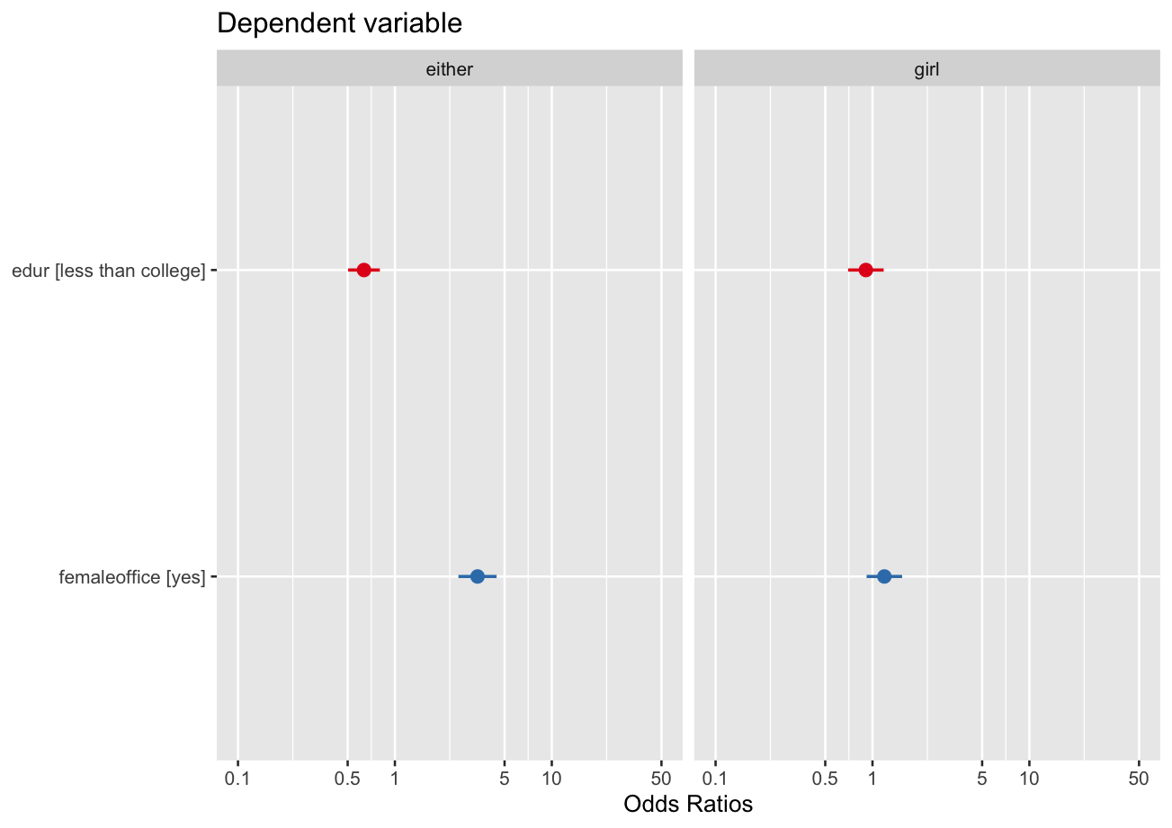

**Interpretation of plot of odds – This allows us to make a general interpretation about the effect of the predictors on the odds of the outcome without exact interpretation of odds.**

* If one were to have an only child, the odds of choosing either gender compared to preferring a boy, is lower for people with less than college education (confidence interval is to the left of one) and higher for those who will elect a female for public office (confidence interval is to the right of one.
* If one were to have an only child, the odds of preferring a girl compared to a boy, is similar for individuals with college and less than college education, as well as those who would choose or not choose a woman for public office (notice both confidence intervals cross one).

**Step nine - Drawing and interpretation of the effect plots in multinomial regression**

Because there are several response categories in multinomial regression, and since the multinomial logit model involves a comparison with an arbitrarily selected baseline (R does this alphabetically), interpretation of the estimated coefficients can be quite challenging. A useful way to visualize the results is with the “effects display” and by using the “effects package”. This is similar to what we did in multiple linear regression.

In the following we have created the effects display for the example given above. This plot shows the fitted probabilities for the three response categories (boy, girl, either) vary with each predictor (level of education and endorsing women for public office), when the other predictor is fixed to a typical value. The fitted probabilities or $μ_{j}$ (x) are calculated separately for each level of “preferred gender of only child” ; boy, girl, or either,

$μ_{j}\left(x\right)=\frac{exp⁡[η_{j}\left(x\right)]⁡}{1+\sum_{l=2}^{m}{exp⁡[η_{j}\left(x\right)]⁡}}$ for j = 2,…,m

**R Commands for creation of the effects plot**

> boyorgirl<-factor(boyorgirl)

> edur<-factor(edur)

> femaleoffice<-factor(femaleoffice)

> install.packages("effects")

> library(effects)

> plot(allEffects(m1),ask=FALSE)

**You need to let R know that the variables used in the drawing of the effects display are all factors.**

**Effects display resulting from example one model one**



**The panel on the left shows, the probability of preferring the gender of the only child (girl, either, boy) for participants with and without college education.**

**Keeping endorsing women for public office constant**

* The probability of preferring the gender of your only child to be a “girl” is similar for participants with and without college education (0.25 compared to 0.26)
* The probability of having no preference for the gender of your only child (either gender) is higher for college educated participants (0.42 compared to 0.32)
* The probability of preferring the gender of your only child to be a “boy” is lower for participants with without college education (0.33 compared to 0.40)

**The panel on the right shows, the probability of preferring the gender of the only child (girl, either, boy) for participants who endorse women for public office and those who do not.**

**Keeping level of education constant…**

* The probability of preferring the gender of your only child to be a “girl” is pretty close for participants with endorse women for public office and those who do not (0.30 compared to 0.26)
* The probability of having no preference for the gender of your only child (either gender) is higher for participants who endorse women for public office compared to those who do not (0.45 compared to 0.25)
* The probability of preferring the gender of your only child to be a “boy” is lower for participants who endorse women for public office compared to those who do not. (0.50 compared to 0.30)

**Step ten – Something to think about: Choosing the baseline rather than having R choose the baseline for you**

Suppose we wanted “either” gender to be the baseline rather than “boy”, we can tell R to do that for us by using the “**relevel**” function.

**> boyorgirl2 <- relevel(boyorgirl, ref = "either")**

**> newm1<-multinom(boyorgirl2~edur+femaleoffice)**

**> summary(newm1, Wald=TRUE)**

**Coefficients:**

(Intercept) edurless than college femaleofficeyes

boy 0.6432751 0.4535533 -1.212716

girl 0.2062446 0.3567748 -1.038237

**Std. Errors:**

(Intercept) edurless than college femaleofficeyes

boy 0.1531751 0.1187042 0.1428201

girl 0.1670606 0.1301348 0.1557581

**Value/SE (Wald statistics):**

(Intercept) edurless than college femaleofficeyes

boy 4.199607 3.82087 -8.491214

girl 1.234550 2.74158 -6.665701

Residual Deviance: 3663.048

**AIC: 3675.048**

**As you notice above now we have two logit models one comparing boy with either and the other comparing girl with either.**

**Example two**

We will now add a numerical predictor to the model we had in example one.

**We want to predict the preferred gender of the only child from attitude toward women’s leadership, level of education, and endorsing females for public office.**

**> library(nnet)**

**> m2<-multinom(boyorgirl~leadership+edur+femaleoffice)**

**> summary(m2, WALD=TRUE)**

> summary(m2, Wald = TRUE)

Coefficients:

(Intercept) leadership edurless than college femaleofficeyes

either -1.8226242 **0.031** -0.5322737 0.83338031

girl -0.4015504 0.009179851 -0.4350789 -0.08283608

Std. Errors:

(Intercept) leadership edurless than college femaleofficeyes

either 0.3150304 0.004510496 0.1972414 0.2321198

girl 0.2990580 0.004937670 0.2087946 0.2086413

Value/SE (Wald statistics):

(Intercept) leadership edurless than college femaleofficeyes

either -5.785550 **6.895531** -2.698590 3.5903025

girl -1.342718 **1.859146** -2.083765 -0.3970263

Residual Deviance: 1484.571

AIC: 1500.571

**Based on the Z value leadership is significant for either gender and not for girl. This means for people who endorse leadership in women, the odds of having no preference for the gender of only child increases.**

**Step eleven - Calculating the accuracy for m1 and m2 through the confusion matrix**

> table(boyorgirl)

boyorgirl

boy either girl

755 814 553

Total = (755 + 814 + 553) = 2122

> library(nnet)

> m1<-multinom(boyorgirl~edur+femaleoffice)

# weights: 12 (6 variable)

initial value 1915.979831

iter 10 value 1831.529077

final value 1831.524218

converged

> p<-predict(m1,boyorgirl)

> tab<-table(p,boyorgirl)

> tab

**Actual**

boyorgirl

**predicted**  boy either girl

boy 232 87 139

either 417 567 302

girl 0 0 0

**Accuracy of m1** = (boy,boy)+(either,either)+ (girl/girl)/Total N

(232+567+0)/(232+87+139+417+567+302+0+0+0) = **0.4581422**

Accuracy calculated above and accuracy based on testing data (see next page) are very similar **(0.458 vs. 0.428).** You might wonder why the accuracy of this model is so low.

Naturally there are many other factors that affect choosing the gender of the only child and that is why we do not have a high accuracy due to multiple confounding factors and this happens a lot in social science research.

**Calculation of accuracy by dividing the data into testing and training and using the caret package**

R codes

> set.seed(123)

> library(nnet)

> library(caret)

> set.seed(123)

> rain_index <- createDataPartition(sex_discrimination$boyorgirl, p = 0.7, list = FALSE)

> train_data <- sex_discrimination[train_index, ]

> test_data <- sex_discrimination[-train_index, ]

> model <- multinom(boyorgirl ~ edur+femaleoffice, data = train_data)

# weights: 12 (6 variable)

initial value 1339.208380

iter 10 value 1277.397147

final value 1277.397128

converged

> predicted <- predict(model, newdata = test_data)

> conf_matrix <- table(Predicted = predicted, Actual = test_data$boyorgirl)

> print(conf_matrix)

Actual

Predicted boy either girl

boy 150 123 94

either 41 75 42

girl 0 0 0

**Accuracy for m1 based on test data**= (150+75+0)/(150+123+94+41+75+42+0+0+0)

**[1] 0.4285714**

Calculation of accuracy for the model with the additional predictor of leadership (i.e., endorsing leadership in women)

> m2<-multinom(boyorgirl~leadership+edur+femaleoffice)

# weights: 15 (8 variable)

initial value 812.973094

iter 10 value 742.931260

final value 742.285361

converged

> p<-predict(m2,boyorgirl)

> tab<-table(p,boyorgirl)

> tab

boyorgirl

predictred boy either girl

boy 184 88 109

either 84 190 75

girl 2 2 6

**Accuracy for m2 =** (184+190+6)/(184+88+109+84+190+75+2+2+6) = **0.5135135**

**Step twelve - Which model do we choose m1 or m2**

**Comparing m1 and m2 (in m2 we added attitude toward leadership of women)**

**AIC for m1 is much higher than m2 3675. vs 1500**

|  |  |  |  |
| --- | --- | --- | --- |
| Model | predictors | AIC | Accuracy |
| m1 | Education, choosing women for public office | 3675 | 0.46 |
| m2 | Education, choosing women for public office, endorsing women’s leadership | 1500 | 0.51 |

m2 has higher accuracy and lower AIC. So, it looks like adding leadership to the model makes it more accurate and more interesting.

**As for interpretation of leadership, it would help to look at the histogram and summary table**

> summary(leadership)

Min. 1st Qu. Median Mean 3rd Qu. Max. NA's

0.00 35.71 42.86 49.98 64.29 100.00 1335

The range is 100 and the histogram looks pretty good. The log of odds of leadership is 0.031 comparing being OK with either gender for only child compared with preferring a boy.

If we exponentiate 0.031, we get

Exp(0.031)= 1.031486

**Interpretation**. If we increase endorsing leadership of women by one unit, the odds of being indifferent to the gender of only child vs wanting a boy increases by 3%.

Let us exponentiate to 10 points.

> exp(0.31)

[1] 1.363425

**Interpretation**. If we increase endorsing leadership of women by ten points, the odds of being indifferent to the gender of only child vs wanting a boy increases by 36%.

So, it looks like endorsing the leadership of women has got a lot to do with attitude about the gender of the only child and m2 is a more interesting and accurate model.

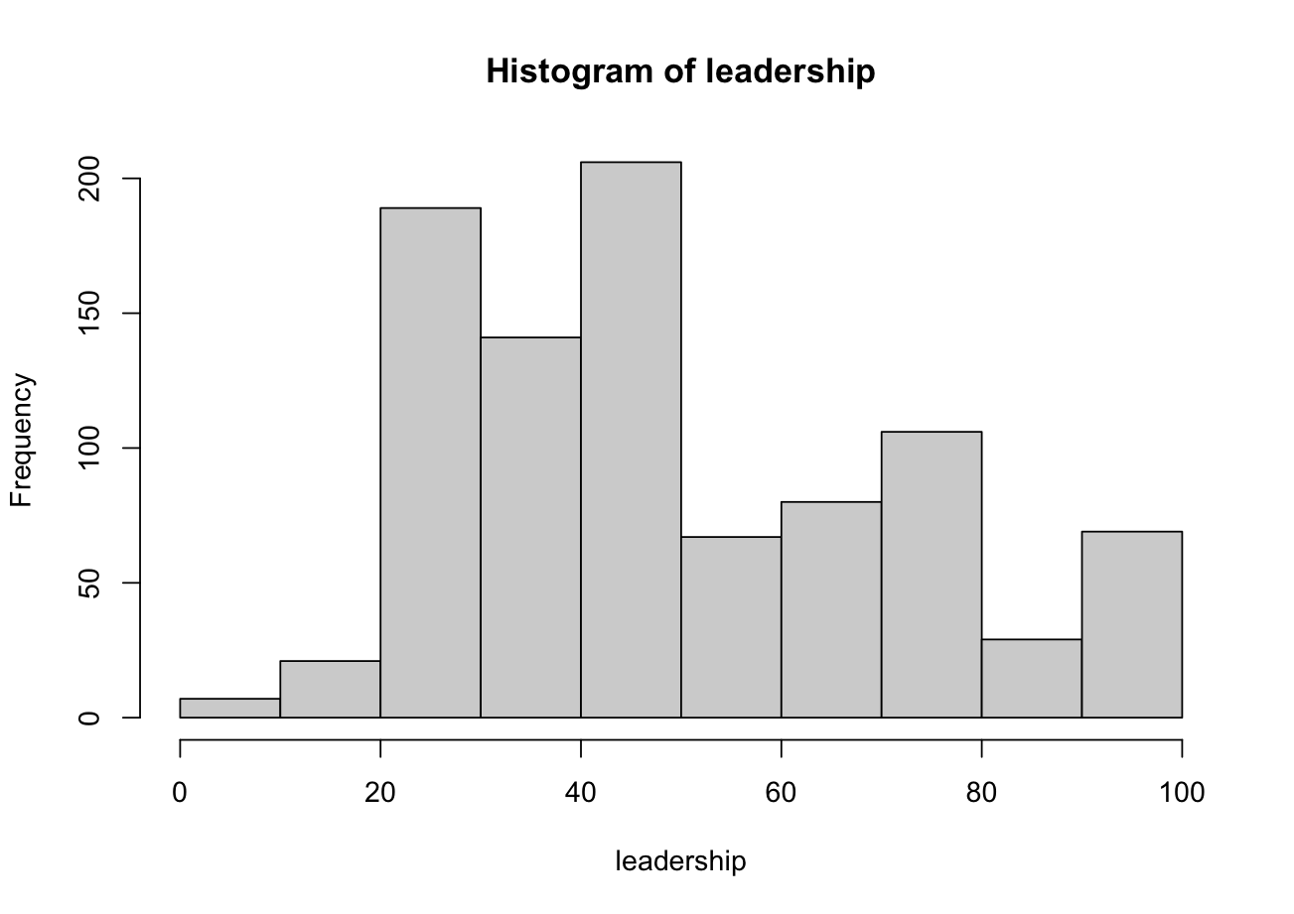

**Plot of odds for m2**

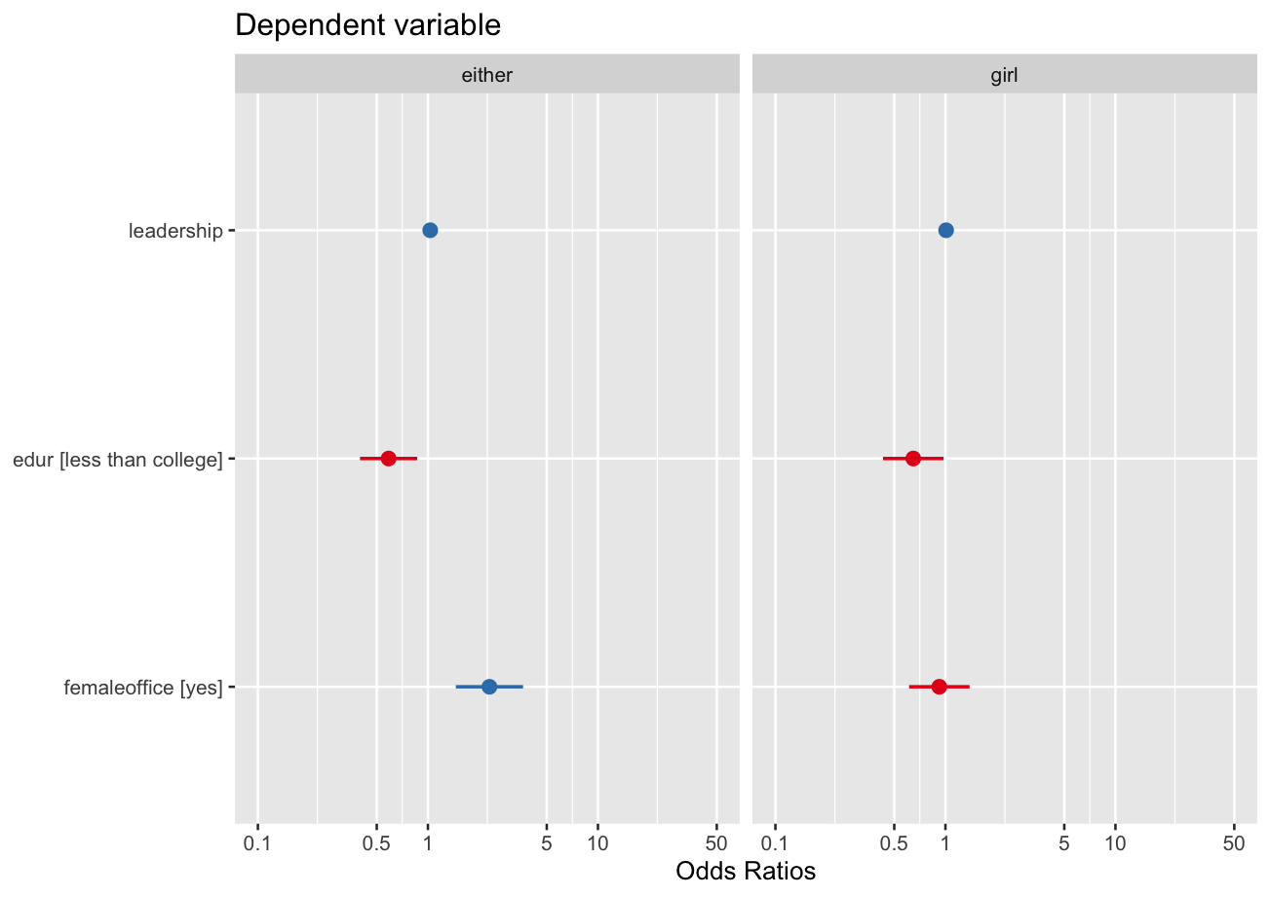

**In the following you are given some questions to help you practice with multinomial regression.**

**Question one. What do you conclude from the analysis of deviance table?**

>library(car)

**> Anova(m2)**

**Analysis of Deviance Table (Type II tests)**

Response: boyorgirl

LR Chisq Df Pr(>Chisq)

leadership 56.730 2 4.8e-13 ***

edur 8.170 2 0.0168245 *

femaleoffice 17.593 2 0.0001513 ***

---

Signif. codes: 0 ‘***’ 0.001 ‘**’ 0.01 ‘*’ 0.05 ‘.’ 0.1 ‘ ’ 1

**> library(effects)**

**> plot(allEffects(m2), ask=FALSE)**

**Question two. How would you interpret the following plot?**



> exp(coef(m2))

(Intercept) leadership edurless than college femaleofficeyes

**either 0.1616011 1.031591 0.5872682 2.301084**

girl 0.6692816 1.009222 0.6472136 0.920502

**You could use the following commands to estimate the Z and P values associated with the coefficient in the multinomial model.**

> z <-summary(m2)$coefficients/summary(m2)$standard.errors

> z

(Intercept) leadership edurless than college femaleofficeyes

either -**5.785550 6.895531 -2.698590 3.5903025**

girl -1.342718 1.859146 -2.083765 -0.3970263

p <- (1 - pnorm(abs(z), 0, 1))*2

> p

(Intercept) leadership edurless than college femaleofficeyes

either **7.227533e-09 5.366374e-12 0.006963384 0.0003302944**

girl 1.793634e-01 6.300639e-02 0.037181584 0.6913480395

**Question four.** Interpret the odds ratio associated with “either gender” compared to “boy” using the coefficients, Z, and P-values given above.

**Question three.** We will now try a model with a categorical variable and interaction effect between two categorical variables.

**We are going to look at the effect of community type (urban, rural, and suburban) as well as the combined effect of level of education and endorsing women for public office on the preferred gender of only child.**

**> table(communitytype)**

communitytype

R S U

445 986 814

**> table(edur,femaleoffice)**

femaleoffice

edur no yes

college 111 582

less than college 358 776

**Frequencies within the different cells look reasonable**

>m3<-multinom(boyorgirl~communitytype+edur*femaleoffice)

>summary(m3, Wald = TRUE)

Coefficients:

(Intercept) communitytypeS communitytypeU edurless than college femaleofficeyes

either -1.4026892 0.1219191 -0.1223524 0.5311388 2.0779973

girl -0.9028228 0.3877580 0.2283606 0.1995797 0.4471004

edurless than college:femaleofficeyes

either -1.1687215

girl -0.3867398

Std. Errors:

(Intercept) communitytypeS communitytypeU edurless than college femaleofficeyes

either 0.3125249 0.1535983 0.1586036 0.3217149 0.3067262

girl 0.2593622 0.1720856 0.1767107 0.2522655 0.2522806

edurless than college:femaleofficeyes

either 0.3479699

girl 0.2968047

Value/SE (Wald statistics):

(Intercept) communitytypeS communitytypeU edurless than college femaleofficeyes

either -4.488248 0.7937534 -0.7714352 1.6509612 **6.774763**

girl -3.480934 **2.2532856** 1.2922852 0.7911491 1.772234

edurless than college:femaleofficeyes

either **-3.358685**

girl -1.303011

Residual Deviance: 3635.318

AIC: 3659.318

**> Anova(m3)**

**Analysis of Deviance Table (Type II tests)**

Response: boyorgirl

LR Chisq Df Pr(>Chisq)

communitytype 8.325 4 0.080376 .

edur 15.837 2 0.000364 ***

femaleoffice 85.489 2 < 2.2e-16 ***

edur:femaleoffice 12.328 2 0.002104 **

---

Signif. codes: 0 ‘***’ 0.001 ‘**’ 0.01 ‘*’ 0.05 ‘.’ 0.1 ‘ ’ 1

**What do you conclude from the above ANOVA table?**

**Can you make a connection between these results and the Wald Test?**

**Creation of the effects plot**

You need to let R know that community type is a factor.

> library(car)

> library(effects)

> communitytype<-factor(communitytype)

> plot(allEffects(m3),ask=FALSE)



**Summarize the results from model three.**

**Question four: Multinomial model with interaction between a numerical and a categorical variable**

We are interested in predicting the preferred gender of only child from endorsing women for public office and the combined effect of attitude toward women’s leadership with level of education.

> m4<-multinom(boyorgirl~femaleoffice+leadership*edur)

> summary(m4,Wald=TRUE)

Call:

multinom(formula = boyorgirl ~ femaleoffice + leadership * edur)

Coefficients:

(Intercept) femaleofficeyes leadership edurless than college leadership:edurless than college

either -2.404331 0.84057487 0.04353710 0.3134133 -0.01840542

girl -1.148831 -0.07512195 0.02529882 0.7027545 -0.02538466

Std. Errors:

(Intercept) femaleofficeyes leadership edurless than college leadership:edurless than college

either 0.4440181 0.2318694 0.007872769 0.5080321 0.009527919

girl 0.4270179 0.2088005 0.008257068 0.5046177 0.010215506

Value/SE (Wald statistics):

(Intercept) femaleofficeyes leadership edurless than college leadership:edurless than college

either -5.414939 **3.6252079** **5.530086** 0.6169163 -1.931736

girl -2.690357 -0.3597786 **3.063898** 1.3926474 **-2.484915**

Residual Deviance: 1477.72

AIC: 1497.72

**We can assume that any Z-value larger than two is statistically significant (see bolded above under Wald statistics)**

**> Anova(m4)**

**Analysis of Deviance Table (Type II tests)**

Response: boyorgirl

LR Chisq Df Pr(>Chisq)

femaleoffice 17.693 2 0.0001439 ***

leadership 56.730 2 4.8e-13 ***

edur 8.170 2 0.0168245 *

leadership:edur 6.850 2 0.0325422 *

---

Signif. codes: 0 ‘***’ 0.001 ‘**’ 0.01 ‘*’ 0.05 ‘.’ 0.1 ‘ ’ 1

> exp(coef(m4))

(Intercept) femaleofficeyes leadership edurless than college leadership:edurless than college

either 0.0903259 2.3176990 1.044499 1.368087 0.9817629

girl 0.3170073 0.9276304 1.025622 2.019307 0.9749348

*> confint(m4)*

*, , either*

*2.5 % 97.5 %*

*(Intercept) -3.27459061 -1.5340714991*

*femaleofficeyes 0.38611914 1.2950305894*

*leadership 0.02810675 0.0589674400*

*edurless than college -0.68231140 1.3091380019*

*leadership:edurless than college -0.03707980 0.0002689581*

*, , girl*

*2.5 % 97.5 %*

*(Intercept) -1.985770312 -0.311890849*

*femaleofficeyes -0.484363471 0.334119567*

*leadership 0.009115259 0.041482373*

*edurless than college -0.286277983 1.691786984*

*leadership:edurless than college -0.045406686 -0.005362636*

> library(effects)

> plot(allEffects(m4), ask = FALSE)



**Summarize the results from model four.**

**Useful YouTubes on multinomial lecture and estimation of accuracy**

Conducting multinomial regression

[**https://www.youtube.com/watch?v=S2rZp4L_nXo**](https://www.youtube.com/watch?v=S2rZp4L_nXo)

Measurement of accuracy

[**https://www.youtube.com/watch?v=POyTaeneHJY**](https://www.youtube.com/watch?v=POyTaeneHJY)